Using the Canadian Revenue Agency PDOC
This is an example of how to use the CRA’s Payroll Deductions Online Calculator (PDOC).

Example
Simon Simple earns a gross weekly wage of $650 (Claim Code 1). He has a weekly RPP deduction of $18.50 and weekly union dues deduction of $4.50. Use the PDOC to calculate his net pay and state the solution as a Net Pay Summary.

Steps
- Go to: http://www.cra-arc.gc.ca/esrvc-srvce/tx/bsnss/pdoc-eng.html
- Click “I accept”
- Click “Begin”
- 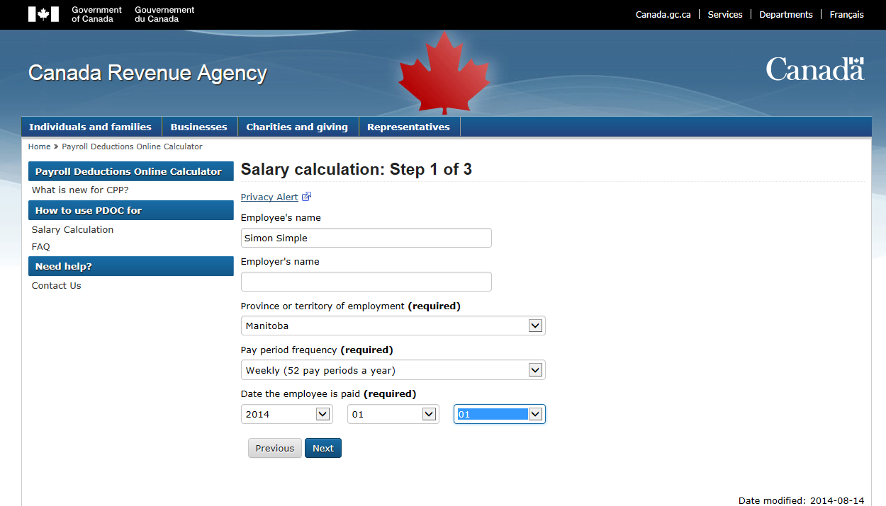Enter the employee’s name in the space provided and enter "Manitoba" as the province, weekly for the number of pay periods, and select “2014”, “01”, “01” as the date the employee is paid, click “Next”
5. Enter the gross pay and if applicable, check the union dues and RPP, click “Next”

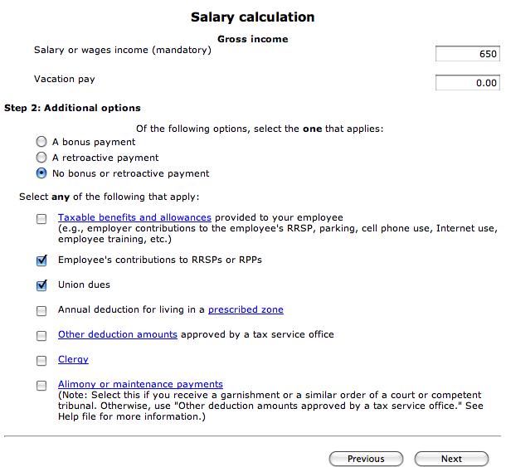

- If you had union dues or RPP deductions, enter the amounts in the appropriate lines, click “Next”
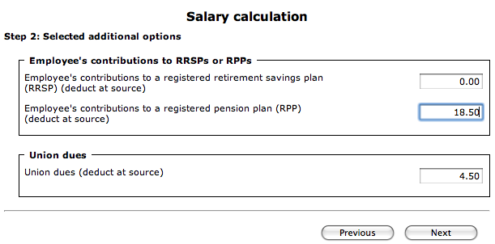
- At the salary calculation page you will need to select the claim code for your scenario, use the drop down menu for the federal TD1 form and the provincial TD1 form (the claim code values are shown in the charts below)
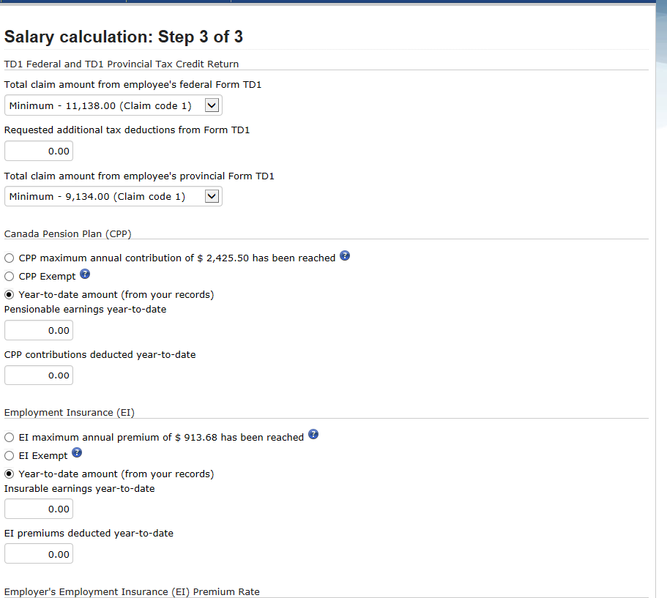

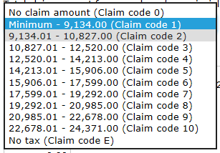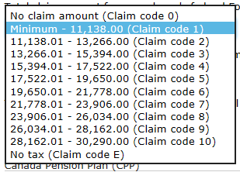

Click “calculate”
- The resulting screen is the net pay summary:
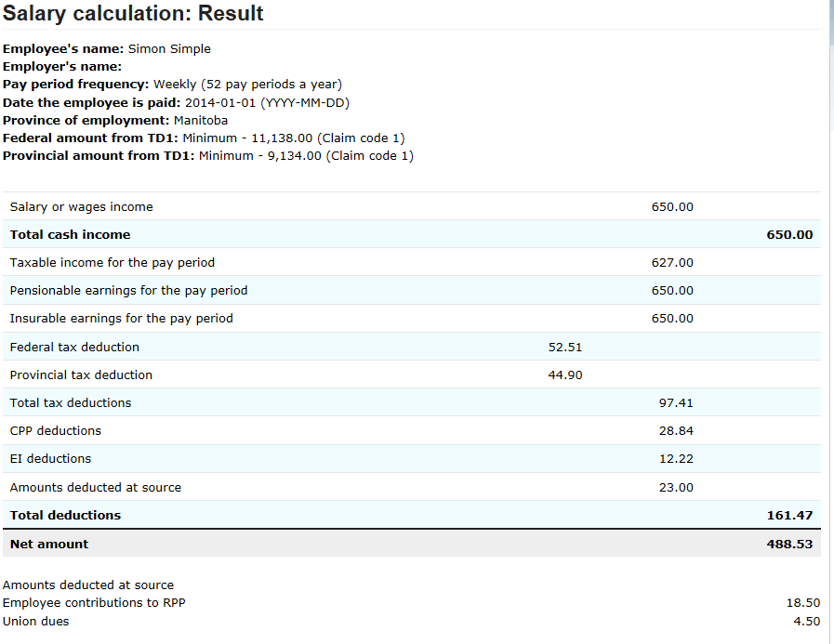
Net Pay Summary (this is the solution I want for the assignment)
GROSS PAY = $650.00
CPP = $28.84
EI = $12.22
TAXABLE INCOME = $627.00
INCOME TAX = $97.41
TOTAL DEDUCTIONS = $161.47 (this included the RPP and union dues)
NET PAY = $488.53

