Major Trig Hand-In

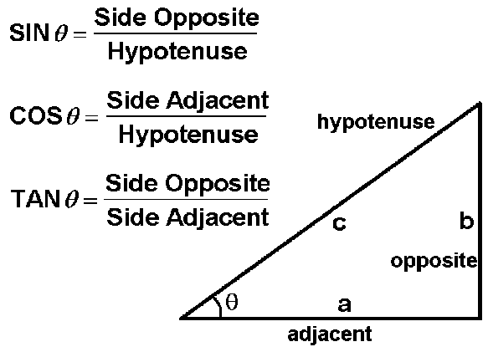

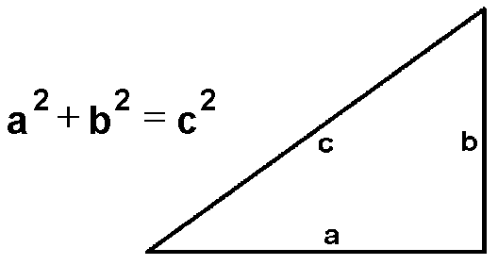

Name:_____________________
SINE

1. In each triangle, name the side:
a) opposite∠A
b) adjacent to ∠A
c) that is the hypotenuse

R R G

G A A

2. For each triangle, what ratio is use to express each value?
a) sin A
b) sin G

3. Find each value of x:
a) b)
10 cm
12 cm
7°
X

X
12°

4. In each triangle, one acute angle and the length of one side are given. Calculate the lengths of the other two sides
a) b)
B
50°

C D

7 cm
35°
W
18 m
R S

5. Calculate each value of x to 1 decimal place.
a) b)
A D
9.9 m
X
E
B
17°
X
30 cm
60°
F
C

6. The diagonal of a rectangle is 15 cm long. It makes a 20° angle with one of the sides. Calculate the width of the rectangle.

7. A rollercoaster climbs vertically 60m at an angle of 25° from the lowest to the highest point of the track. It then plunges over the high point to being the ride. Calculate the length of track that brings the roller coaster from the ground to the highest point.
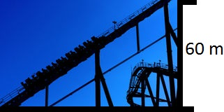

8. Francesco is flying a kite on a string 150m long. The string makes an angle of 68° with the ground. Suppose Francesco is holding the end of the kite string 2m above the ground. How high is the kite?

Cosine

1. In ∆ABC, ∠B=90° and AC=25m
a) ∠A = 15° b) ∠C = 65°
Find AB Find BC

C
25 m

B A

2. Calculate the measure of X in these triangles
a) b)
P F
22°
25°
22 m
31 cm
X
Q
N E
X
M

3. Calculate the length of BC given ∠C=78°
C
25 m

B A

4. Find X
a) b)
15 cm
20 m
X
6°
17°
X

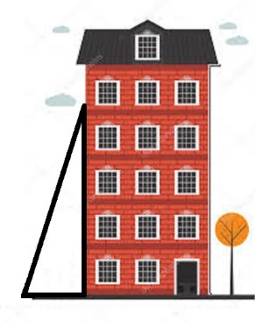
5. A 10m ladder leans against a vertical wall at an angle of 73°.

10 m

73°

a) Calculate the height the ladder reaches up the wall.
b) Calculate the distance from the foot of the ladder to the wall.

6. The sun’s rays are at an angle of 42° to the ground. A hydro pole casts a shadow 18m long. Calculate the height of the pole.

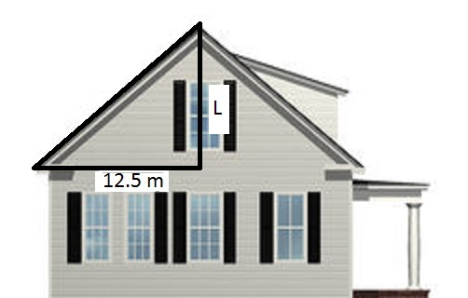
7. The diagram below shows a house designed for solar heating. Calculate the length of L of the solar collectors.

6°

8. The longest side of a rectangle is 22cm. The diagonal of the rectangle makes an angle of 32° with this side.
a) Calculate the width of the rectangle
b) Calculate the length of the diagonal

Tangent

1. Find the missing side
a) b) 59.8
X
16.5
68°

X
32°

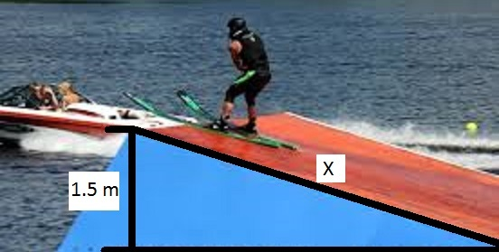
2. A water ski ramp floats on the surface of a lake. The ramp rises 1.5m above the water at its highest point. The edge of the ramp along the level surface of the water is 5.0m. Find the length of the ramp.
5 m

3. The sun’s rays are at an angle of 38° to the ground. A tree casts a shadow 42m long. Calculate the height of the tree.

4. A radio tower is 350m high. The sun’s rays make an angle of 39° with the ground. Calculate the length of the tower’s shadow.

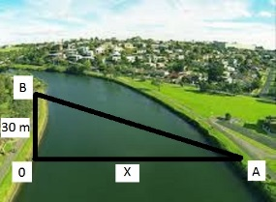
5. In the diagram, an observer at O is directly opposite a tree at A on the other side of a river. Another tree at B, on the same side of the river as O, is 30m from O. ∠B = 64° and ∠O = 90°. Calculate the distance from O to A.

6. Find X

a) b)
60°

X X
31°

18.2 24

c) 94 d) X
23°
22.5
X
62°

Working with Mathematics
1. Calculate ∠A in each triangle.
a) B C b) L
19 m
9 cm
6 cm
16 m
A T A
c) A d)
M
9 cm
15 m

12 cm
10 m
G R T A
2. Calculate tan A and ∠A to the nearest degree, then calculate tan B and ∠B to the nearest degree. Check the results by showing that the sum of the three angles in each triangle is 180°
a) B b) A
6 cm
10 m
8 cm
17 cm
8 cm
15 cm
A C C B
3. Calculate sin A and ∠A. Calculate sin C and ∠C. Check the results by showing that the sum of the three angles in each triangle is 180°
a) C b) A
12 m
20 m
26 m
10 m
24 m
16 m
A B B C
4. In ∆JKL, calculate tan K and ∠K to the nearest degree for each length of JL
a) 8 m b) 12 m
J
5 m
K
L

5. The foot of a 6m ladder is on a level patio 1.5m from the wall against which it leans.
a) Find the angle formed by the ladder and the ground.
b) Calculate how high up the wall the ladder reaches.

6. A rectangle measures 16cm by 12cm. Calculate the measure of the acute angle formed by the intersection of its diagonals.

7. A guy wire is 15m long. It supports a television tower. The wire is fastened to the ground 9.6m from the base of the tower.
a) Calculate the measure of the angle formed by the guy wire and the ground.
b) How far up the tower is the guy wire?

8. Calculate∠ A in each triangle
a) C b) A P
5 cm
12 cm
4 cm
10 cm

A B Q
c) d) A
J
8 m
5 m
16 cm

P A W D
18 cm

