Essential Math 30S – Formula Sheet

Part A: Interest and Credit

Simple Interest:
I
$$I = P r t$$
or
t
r
P

Compound Interest:
$$A=P{\left[1+\frac{r}{n} \right]}^{nt}$$

Rule of 72:
$$t= \frac{72}{r}$$

Personal Loans:

$$monthly payment= \left[\frac{loan amount}{1000} x ammortization table value\right]$$

Amortization Table
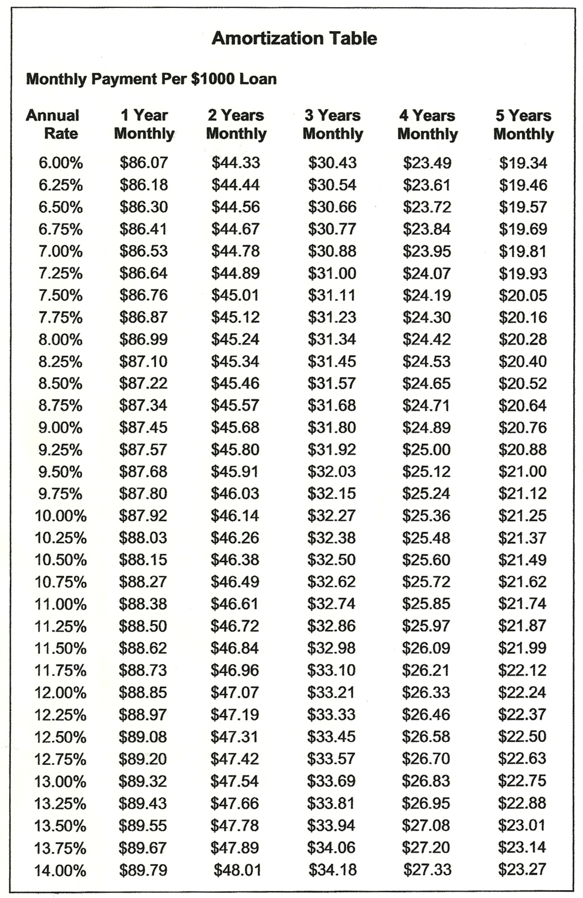

Part D: Patterns and Relations

Slope:
$$m= \frac{y -y }{x -x }$$
1
1
$$slope= \left[\frac{change in dependent value }{change in independent value }\right]$$
2
$$slope= \frac{rise}{run}$$
2

Equation of a Line:
$$y=mx+b$$

Part E: Trigonometry

B
*Angles inside a triangle add up to 180°.
c
a

Pythagorean Theorem:
$$a^{2}+b^{2}=c^{2}$$
C
A
b

Trigonometric Ratios:

$$\cos{θ}=\frac{adj}{hyp}$$

$$\tan{θ}=\frac{opp}{adj}$$
$$\sin{θ}=\frac{opp}{hyp}$$

Part F: Geometry

GEOMETRIC FIGURE | SURFACE AREA | VOLUME
CUBE  s | SA = 6s² | V = s³
RECTANGULAR PRISM  h  $$l$$  w | SA = 2$l$w + 2$l$h + 2wh | V = $l$wh
TRIANGULAR PRISM  a  c  h  $$l$$  b | SA = bh + (a + b + c)$l$ | V = $\frac{1}{2}$bh x $l$
CYLINDER  r  h | SA = 2πr² + 2πrh | V = πr²h
SQUARE PYRAMID  h  s  b  b | SA = 2bs + b² | V = $\frac{1}{3}$b²h
CONE  s  h  r | SA = πr² + πrs | V =$\frac{1}{3}$πr²h
SPHERE  r | SA = 4πr² | V = $\frac{4}{3}$πr³

METRIC
X 1000
X 100
X 10

meter (m)
litre (L)
gram (g)
centi
milli
kilo

÷ 1000
÷ 10
÷ 100

IMPERIAL
X 3
X 1760
X 12

inch (in)
foot (ft)
mile (mi)
yard (yd)

÷ 12
÷ 3
÷ 1760

METRIC | IMPERIAL
Length
1 mm | 0.0394 in
1 cm = 10 mm | 0.3937 in
1 m = 100 cm | 1.0936 yd
1 km = 1000 m | 0.6214 mi
2.54 cm | 1 in
0.3048 m | 1 ft = 12 in
0.9144 m | 1 yd = 3 ft = 36 in
1.6093 km | 1 mi = 1760 yd = 5280 ft
Area
1 cm² | 0.1550 in²
1 m² | 10.76391 ft²
1 m² | 1.1960 yd²
1 km² | 0.3861 mi²
6.4516 cm² | 1 in²
0.0929 m² | 1 ft² = 144 in²
0.8361 m² | 1 yd² = 9 ft² = 1296 in²
2.59 km² | 1 mi²
Volume
1 cm³ | 0.0610 in³
1 m³ | 35.3147 ft³
1 m³ | 1.30795 yd³
16.4 cm³ | 1 in³
0.0283 m³ | 1 ft³
0.765 m³ | 1 yd³
METRIC | IMPERIAL
Capacity
28.41 mL | 1 oz
56.26 mL | 1 pint
1 L | 1000 cm³
1000 L | 1 m³
1.1365 L | 1 quart = 2 pints
4.546 L | 1 gallon = 2 quarts
Mass
1 kg = 1000 g | 2.2 pounds
454 g | 1 pound = 16 oz
28.4 g | 1 oz

METRIC | METRIC
Capacity
1 ml | 1 cm³
1 L | 1000 cm³
1000 L | 1 m³

IMPERIAL | IMPERIAL
Capacity
6.25 gallons | 1 ft³
Mass
0.5787 fl oz | 1 in³

Part G: Design Modelling

Scale Factor:

$$scale factor= \frac{diagram}{actual}$$

2D Geometry:
