Essential Math 20S – Formula Sheet

Part B: Unit Pricing and Currency
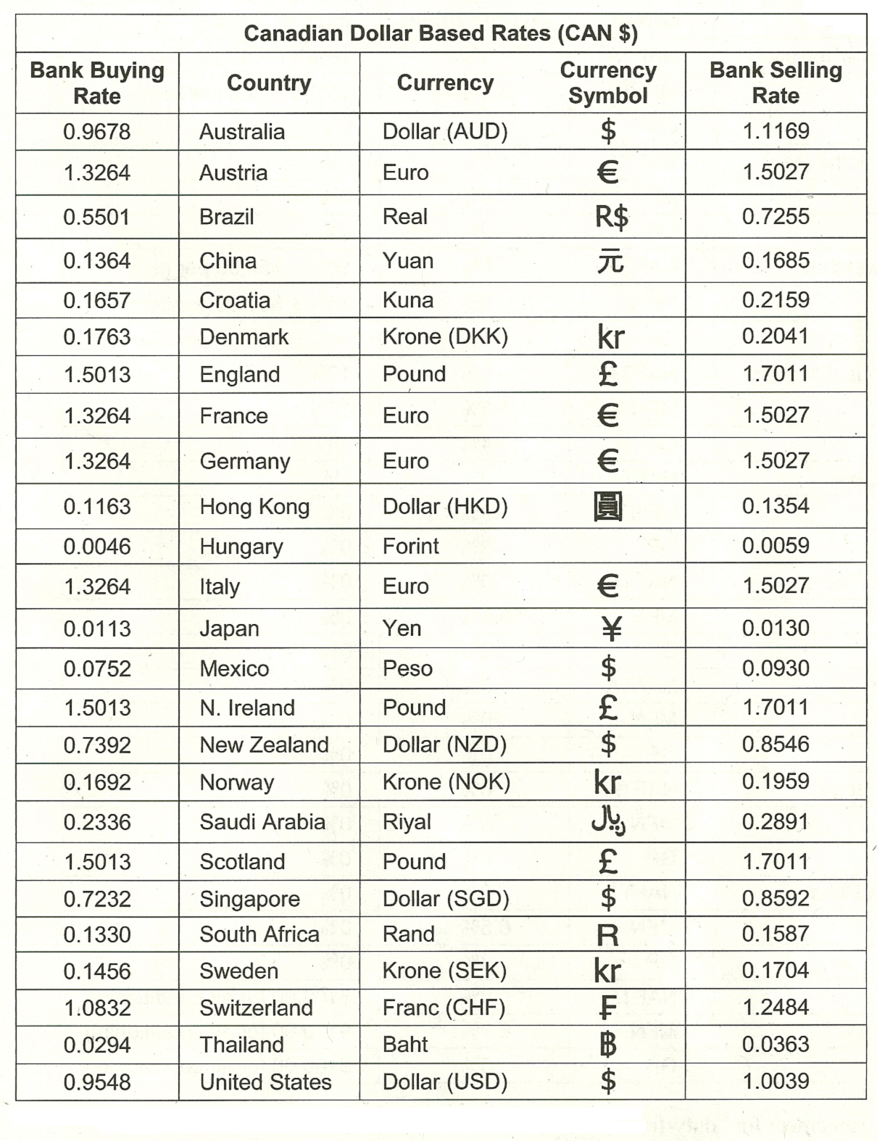

Part D: Measurement

COOKING

Volume (Cooking)
1 tsp | 5 ml
1 tbsp | 15 ml
1 cup | 250 ml
4 cups | 1 litre
Weight (Cooking)
1 oz | 28 g
1 lb | 448 g
2.2 lbs | 1 kg
*There are 16 oz in 1 lb.

Acceptable Rounding for Cooking Conversions
Decimal Value After Conversion  ** | Fractional Value Estimate
0.0 – 0.19 | 0
0.20 – 0.29 | 1/4
0.30 – 0.39 | 1/3
0.40 – 0.59 | 1/2
0.60 – 0.69 | 2/3
0.70 – 0.79 | 3/4
0.80 – 0.99 | 1

** If the measurement works out to be between 0.0 – 0.19, you still need to add some of this
item such as Salt, Baking Soda, or Baking Powder. Make the measurement a Pinch or Dash.

TEMPERATURE
$$C= \frac{5}{9}\left(F-32\right)$$

$$F= \frac{9}{5}C+32$$

Conversions within Systems

METRIC
X 1000
X 100
X 10

centimeter (cm)
millimeter (mm)
kilometer (km)

meter (m)

÷ 100
÷ 10
÷ 1000

IMPERIAL
X 12
X 1760
X 3

yard (yd)
mile (mi)
foot (ft)
inch (in)

÷ 12
÷ 3
÷ 1760

Metric | Imperial
Length  10 mm = 1 cm  100 cm = 1 m  1000 m = 1 km | Length  12 in = 1 ft  36 in = 3 ft = 1 yd  5 280 ft = 1 760 yd = 1 mi
Area  100 mm² = 1 cm²  10 000 cm² = 1 m²  1 000 000 m² = 1 km² | Area  144 in² = 1 ft²  1 296 in² = 9 ft² = 1 yd²
Volume  1 000 mm³ = 1 cm³  1 000 000 cm³ = 1 m³ | Volume  1 728 in³ = 1 ft³  46 656 in³ = 27 ft³ = 1 yd³

Conversion between Systems
METRIC | IMPERIAL
Length
1 mm | 0.0394 in
1 cm | 0.3937 in
1 m | 1.0936 yd
1 m | 39.37 in
1 km | 0.6214 mi
2.54 cm | 1 in
0.3048 m | 1 ft
0.9144 m | 1 yd
1.6093 km | 1 mi
Area
1 cm² | 0.1550 in²
1 m² | 10.76391 ft²
1 m² | 1.1960 yd²
1 km² | 0.3861 mi²
6.4516 cm² | 1 in²
0.0929 m² | 1 ft²
0.8361 m² | 1 yd²
2.59 km² | 1 mi²
Volume
1 cm³ | 0.0610 in³
1 m³ | 35.3147 ft³
1 m³ | 1.30795 yd³
16.4 cm³ | 1 in³
0.0283 m³ | 1 ft³
0.765 m³ | 1 yd³
Capacity
28.41 mL | 1 oz
568.26 mL | 1 pint
1.1365 L | 1 quart (2 pints)
4.546 L | 1 gallon (4 quarts)
3.7854 L | 1 USA gallon

Part E: Geometry
GEOMETRIC FIGURE | PERIMETER | AREA
SQUARE  $$s$$ | $$P=4s$$ | $$A=s^{2}$$
RECTANGLE  $$l$$  $$w$$ | $$P=2\left(l+w\right)$$  $$P=2l+2w$$ | $$A=lw$$
PARALLELOGRAM  $$h$$  $$c$$  $$b$$ | $$P=2(b+c)$$  $$P=2b+2c$$ | $$A=bh$$
TRIANGLE  $$a$$  $$h$$  $$c$$  $$b$$ | $$P=a+b+c$$ | $$A=\frac{bh}{2}$$  $$A=\frac{1}{2}bh$$
TRAPEZOID  $$a$$  $$d$$  $$c$$  $$h$$  $$b$$ | $$P=a+b+c+d$$ | $$A=\frac{1}{2}\left(a+b\right)h$$
CIRCLE  $$d$$  $$r$$ | $$C=2πr$$  $$C=πd$$ | $$A=πr^{2}$$
REGULAR POLYGON  n = number of sides  s = side length  a = length of apothem | $$P=ns$$ | $$A=\frac{1}{2}ans$$

Part G: Trigonometry

B
*Angles inside a triangle add up to 180°.
c
a

Pythagorean Theorem:
$$a^{2}+b^{2}=c^{2}$$
C
A
b

Trigonometric Ratios:

$$\cos{θ}=\frac{adj}{hyp}$$

$$\tan{θ}=\frac{opp}{adj}$$
$$\sin{θ}=\frac{opp}{hyp}$$

