Fast Facts – Motion
Set 1
1. What is motion?

2. How do we know if an object is in Motion?

3. What does the term Kinematics mean in physics?

4. What does the term Dynamics mean in physics?

5. Scalar quantities can be described as:

6. What does a Vector quantity have that a Scalar quantity does not?

Set 2
1. Position is where an object is in ___________ to another object.

2. Distance is a ________ quantity. The symbol ________ is used for distance.

3. Displacement is a ______________ quantity, which refers to “how far out of _________ an object is”

4. Explain why there are 2 lines across the river, and why they are different lengths?
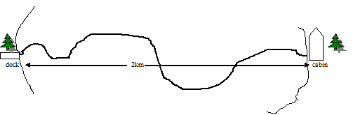

5. Write scalar or vector beside the following quantities:
1. 66 m 2. 11.5 km [North] 3. 7.1 cm 4. 123 mm [Down]

Set 3
1. Periodic motion is motion that _________ itself at regular intervals and does not ___________

2. A period is the length of time required for:

3. The formula for a period is:

4. A brick is dropped from the roof to the ground below. When is hits, it bounces twice in 4 seconds. What is the period?

5. Frequency is the number of vibrations that occur in a unit of _______________

6. The equation for Frequency is:

7. A bird flaps its wings 100 times in 25 seconds. What is the frequency?

Set 4
1. Speed can be defined 2 ways:
1.
2.
2. During constant speed an object will cover the same ___________ for every same interval of _____________

3. When objects move they do not often move at a constant speed but rather they change their speed as they travel. Using this idea we can calculate the ________________________

4. To find the average speed of an object you must know:

5. The formula for average speed is:

6. A jet travels 600 km for an hour and then lands. The jet then takes off again and travels 1400 km in 3 hours. What was the average speed for the time the jet was moving?

Set 5
1. What is definition for Velocity?

2. Constant Velocity is the movement of an object at a constant ___________ and constant _______________. It will always be a ___________ line.
3. To calculate Average Velocity (vav) you need to know the ____________ and the elapsed _____________.

4. A train travels 40 km [W] in 0.5 hr and then travels 22 km [W] in 0.4 hr. What was the average velocity for the train?

Set 6
1. Graph the constant velocity of this object.
- 0 hr – 0 km | - 2 hr – 250 km
- 0.5 hr – 20 km | - 2.5 hr – 50 km
- 1 hr – 120 km | - 3 hr – 0 km
- 1.5 hr – 120 km
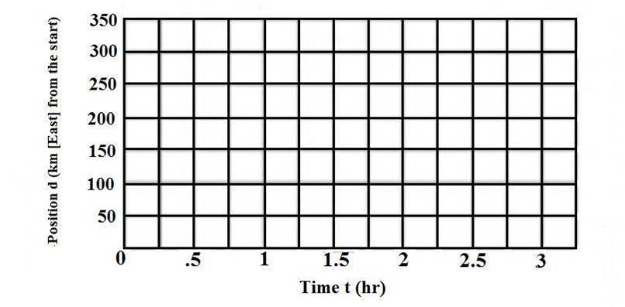

2. What does a steep line indicate on a position vs time graph?

3. What does a flat plateau (line) on a position vs time graph show?

4. If the graph is a round trip, you would expect the end point to be back at zero if the start was originally at zero?

Set 7
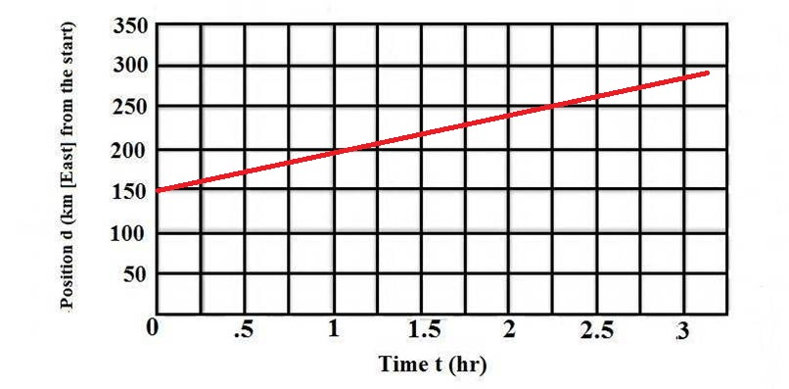
1. Determine the velocity of the object from this graph:

Set 8
1. If an object has a positive acceleration it is _______________. If an object has a negative acceleration it is _________________.

2. The symbol for acceleration is ______________

3. The formula for Acceleration is:
4. Your car is traveling 60km/h [N] when you reach a residential area where the speed limit is 50km/h. It takes you 4 seconds to slow down. What is your average acceleration during this time?

Set 9
1. Newton developed ____ laws that help to explain what causes motion.

2. Newton’s First Law states:

3. Newton’s Second Law states:

4. Newton’s Third Law states:

Set 10
1. The formula for Momentum is:

2. A tank has a mass of 12,000 kg. If it was traveling at 40 km/h [north] what would its momentum be?
3. Impulse deals with changes in momentum. It depends on 2 factors:

4. The formula for impulse is:

5. A baseball pitcher throws a ball with a force of 200 N [forward]. If the ball and his hand are in contact for 0.17s what impulse does the ball receive?

