C:\Users\Owner\Pictures\Microsoft Clip Organizer\j0229885.wmfDREAM ROOM PROJECT

You meet Donald Trump on the street and start talking about math (because that is likely to happen). He is so impressed with your knowledge of 2D geometry that he offers to give you an unlimited amount of money to create your own dream room. It is your job to design the room, complete with a floor plan. You must also create a budget. Mr. Trump will handle the rest.

**Step 1) Floor Plan**

1. **Graph Paper:** Obtain a piece of 1 CENTIMETER graph paper. Your first step is to create your floor plan for your room. On the right hand side of this page are two examples of a real floor plan. You do not need to worry about scale yet. Be creative!
2. **Room Requirements:**

* room shape must be a composite object (at least two regular shapes – do not use irregular).

Doors

Windows

* you must have at least one window and one door.
* you can only have one room with no additional walls in the centre of the room.
* the height of your room is 8 ft – you will use this in step 4.

*\*Make the floor plan large enough on your page so that furniture can easily be drawn.*

**Step 2) Scale**

1. **Ruler:** Using a ruler, measure and label all measurements of your floor plan in cm. Be sure to label all walls, windows, and doors.
2. **Scale:** Choose a scale: 1 cm = ____________ ft
3. **Label Conversions:** Convert and label all measurements on the floor plan into feet based on your scale (use a different colour to label these on your floor plan).

**Step 3) Total Values**

1. **Area:** Calculate the total **AREA** of your dream room in **ft2**. Please show all calculations on your graph paper, next to your floor plan. Record this value in your chart.
2. **Perimeter:** Calculate the total **PERIMETER** of your dream room in **ft**. Please show all calculations on your graph paper, next to your floor plan. Record this value in your chart.

**Step 4) Budget**

When working through these sections, use the accompanying chart page to record all prices and values.

1. **Construction Costs:**  Select one construction type and fill the value into the chart.

* **Type A:** **Basic** **Room** construction costs **$75 per ft2**. A basic room is boring. It includes only the basic features – bed, dresser.
* **Type B:** **Special** **Room** construction costs **$150 per ft2**. A special room includes any special wiring or plumbing – hot tubs, disco lighting, home theatre, etc.

1. **Flooring Costs:** Select one flooring type and fill the value into the chart.

* **Type A: Carpet** costs $1.02/ft2 plus an installation fee of $400.
* **Type B: Tile** costs $5.04/ft2 plus an installation fee of $500.
* **Type C: Hardwood** costs $2.58/ft2 plus an installation fee of $500.

1. **Baseboard Costs:** Select one baseboard type and fill the value into the chart.

* **Type A: Basic Baseboards** cost $2.04/ft plus an installation fee of $300.
* **Type B: Patterned Baseboards** cost $4.05/ft plus an installation fee of $350.

1. **Wall Costs:** Before you can calculate the cost to cover your walls with paint, you must calculate the **paintable dimensions** of each wall (you must subtract any windows and doors). The values you will need include: perimeter of your room, a wall height of 8 ft, area of windows and doors.

* **Type A: Low Quality Paint (No Name)** costs $18.50 per gallon (one gallon covers 200 ft2). Two coats of paint are required.
* **Type B: Medium Quality Paint (Beauti-Tone Paint)** costs $25.00 per gallon (one gallon covers 300 ft2). Two coats of paint are required.
* **Type C: High Quality Paint (Benjamin Moore)** costs $100.00 per gallon (one gallon covers 400 ft2). One coat of paint is required.

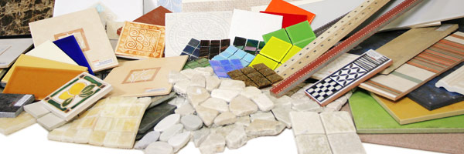

1. **Furnishing Costs:** Although there are many items that you will probably include in your dream room, your job is to select the major furnishings. Choose from the following items for your dream room. If you wish to use other types of furnishings, you may cut out advertisements from flyers/magazines.

**BED**

1. 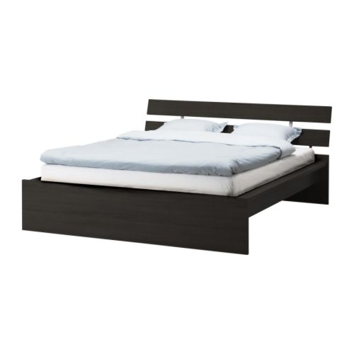Foldaway Bed and Desk 2. Modern Design Bed

*$750 (10 ft x 8 ft)*

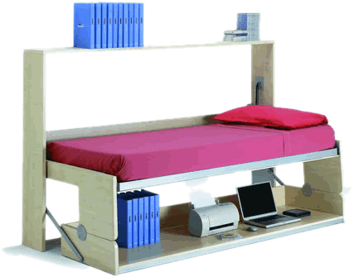

*$600 (8 ft x 4 ft)*

3. Home Theatre Bed 4. Classic Design Bed

*$790 (10 ft x 8 ft)*

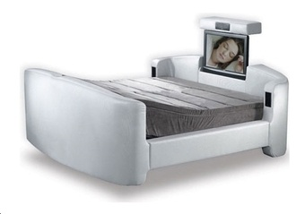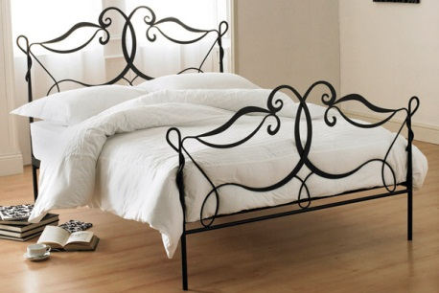

*$1600 (10 ft x 8 ft)*

**DRESSER**

1. Classic White Dresser with Mirror 2. Simple Black Dresser

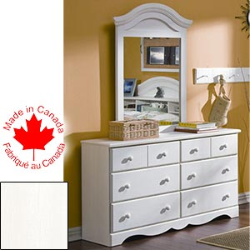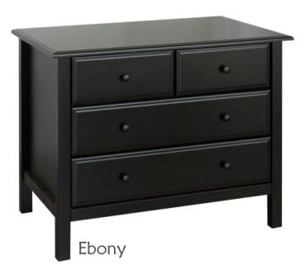

*$400 (5 ft x 1.5 ft)*

*$350 (2 ft x 2 ft)*

3. Wild and Wacky Dresser 4. Modern Black Dresser with Mirror

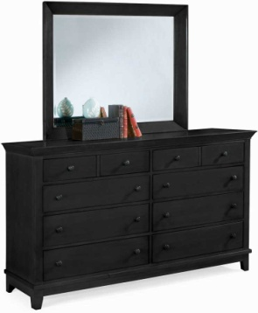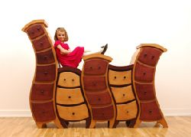

*$750 (6 ft x 2 ft)*

*$450 (5 ft x 2 ft)*

**DESK**

1. Innova L-Shape Work Station 2. Modern Pink Square Desk

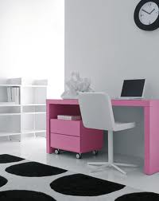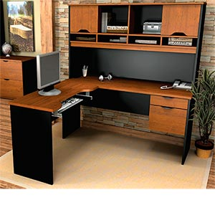

*$250 (5 ft x 2 ft)*

*$500 (5 ft x 5 ft)*

3. Modern White Curve Desk 4. X-Text Computer Desk

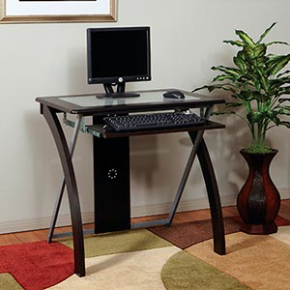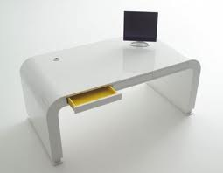

*$100 (3 ft x 2 ft)*

*$150 (5 ft x 3 ft)*

**CHAIRS**

1. Leather Recliner 2. Classic Chair 3. Modern Stool Chair

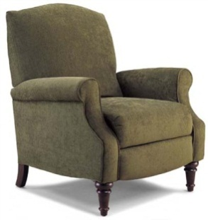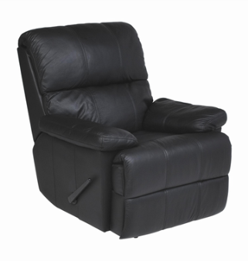

*$300 (2 ft x 3 ft)*

*$50 each (2 ft x 2 ft)*

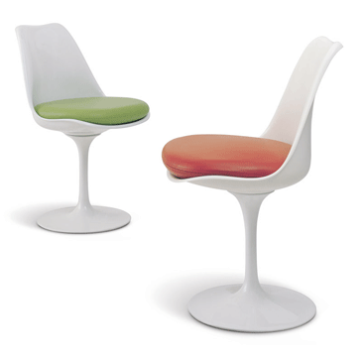

*$800 (3 ft x 3 ft)*

4. Leather Office Chair 5. Bean Bag Cushion 6. Retro Car Loveseat

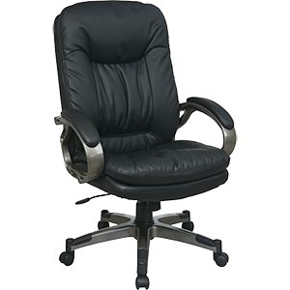

*$130 each (2.5 ft x 3 ft)*

*$180 each (3 ft x 6 ft)*

*$80 each (4 ft x 4 ft)*

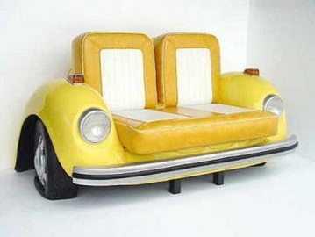

**EXTRAS**

1. 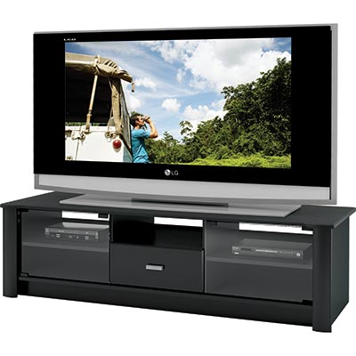Television 2. Television Stand

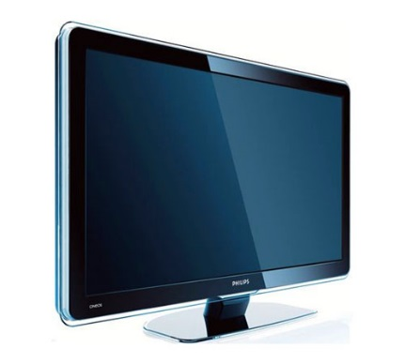

*$650 each (5 ft x 1 ft)*

*$200 each (6 ft x 2 ft)*

3. Hot Tub 4. Computer/Printer Set

*$6000 each (8 ft x 8 ft)*

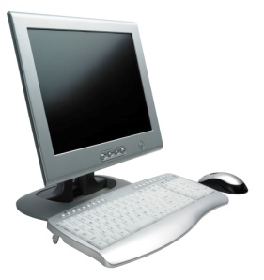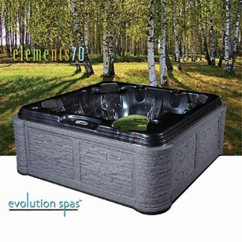

*$1000 each (2 ft x 3 ft)*

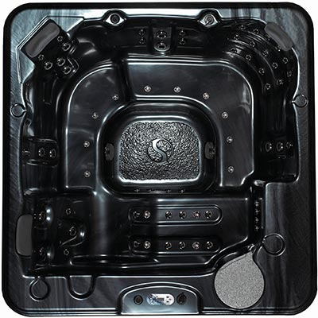

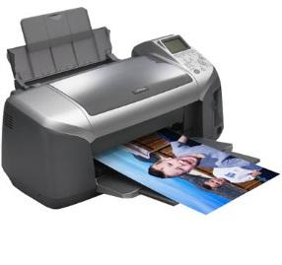

4. Leather Ottoman Storage Set 5. Yorkville Bookcase

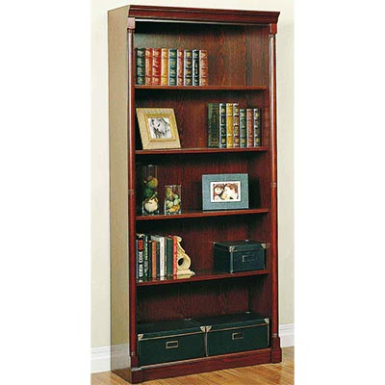

*$760 each (3 ft x 1.5 ft)*

*$500 each (6 ft x 2 ft)*

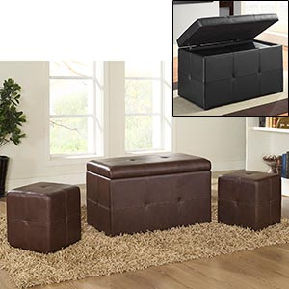

DREAM ROOM CALCULATIONS

**Step 1)** Design On Chart Paper **Step 2)** Scale: 1 cm = _________ ft

**Step 3)** Total Area = _________________ Total Perimeter = _________________

**Step 4)** Budget

|  |  |  |  |
| --- | --- | --- | --- |
| **CONSTRUCTION** | | | |
| **Type** | **Area of Room** | **Cost Per ft2** | **Total Cost** |
|  |  |  |  |

|  |  |  |  |  |
| --- | --- | --- | --- | --- |
| **FLOORING** | | | | |
| **Type** | **Area of Room** | **Cost Per ft2** | **Installation Fee** | **Total Cost** |
|  |  |  |  |  |

|  |  |  |  |  |
| --- | --- | --- | --- | --- |
| **BASEBOARDS** *\*don’t forget to subtract your door* | | | | |
| **Type** | **Perimeter of Room** | **Cost Per ft** | **Installation Fee** | **Total Cost** |
|  |  |  |  |  |

|  |  |  |  |  |
| --- | --- | --- | --- | --- |
| **WALLS** | | | | |
| **Type** | **Area of Walls** | **Cost Per Gallon** | **# of Gallons Needed** | **Total Cost** |
|  |  |  |  |  |

|  |  |  |  |  |
| --- | --- | --- | --- | --- |
| **FURNISHINGS** | | | | |
| **Name** | **Dimensions** | **Cost Per Item** | **# Purchased** | **Total Cost** |
|  |  |  |  |  |
|  |  |  |  |  |
|  |  |  |  |  |
|  |  |  |  |  |
|  |  |  |  |  |
|  |  |  |  |  |
|  |  |  |  |  |
|  |  |  |  |  |
|  |  |  |  |  |

|  |  |
| --- | --- |
| **SUB TOTAL** |  |
| **GST** |  |
| **PST** |  |
| **FINAL COST** |  |

**Step 5) Conclusion**

1. How much money did you spend on your dream room? Did any of the prices surprise you? Why or why not? _______________________________________________________________ ____________________________________________________________________________________________________________________________________________________________
2. What types of occupations/jobs might use this type of math (geometry/area/perimeter)? _______ ____________________________________________________________________________________________________________________________________________________________
3. What did you enjoy most about planning a dream room? ________________________________ ____________________________________________________________________________________________________________________________________________________________
4. What did you enjoy least about planning a dream room? ________________________________ ____________________________________________________________________________________________________________________________________________________________