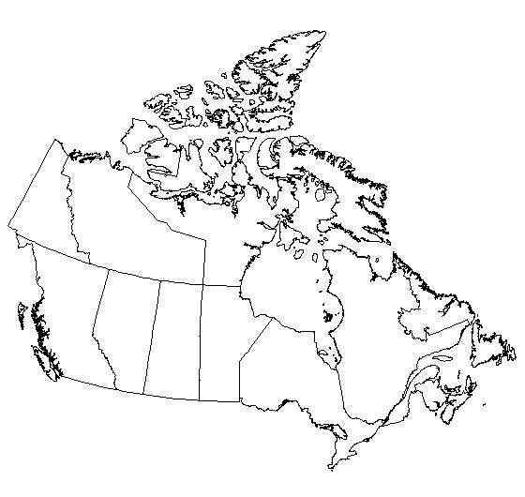**Name: ________________**

**Canada Map Assignment**

**Please complete the following on a map of Canada: /33 marks**

1. Label all the provinces and colour them yellow. /12 marks
2. Label all the territories and colour them orange. /3 marks
3. Label the Oceans on the East, West and North Coast line. /3 marks
4. Label the capital cities with a dot and their name on the map. /12 marks

Don’t forget:

1. Title /1 mark
2. Legend /1 mark
3. Compass Rose /1 mark

