C:\Users\Owner\AppData\Local\Microsoft\Windows\Temporary Internet Files\Content.IE5\3UCABMN4\MC900233966[1].wmfBasic angles hand-in

**Part I: Defining An Angle**

ANGLE: ___________________________________________________________________________

____________________________________________________________________________________

Include a picture below. Your picture must have a vertex, initial arm, and terminal arm.

**Part II: Types of Angles (label each type of angle)**

1. b. c.

_______________ ________________ _______________

**Part III: Supplementary and Complementary**

State the complementary angle to the following values:

1. 63° b. 5.5° c. 24° d. 89°

State the supplementary angle to the following values:

1. 63° f. 55° g. 45.8° h. 166°

State the corresponding angle (use math… DO NOT MEASURE):

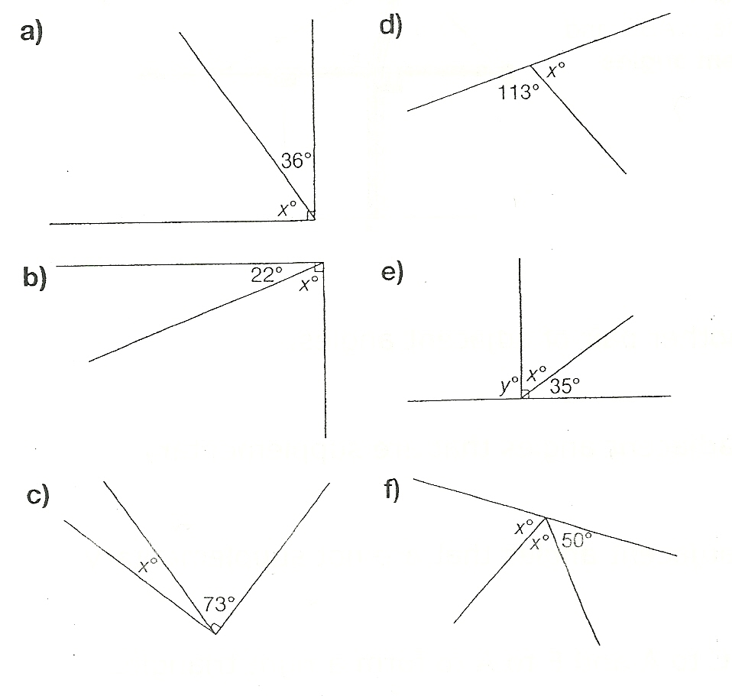

**Part IV: Measure Each Angle – Name ( ABC) and Classify (acute/obtuse/reflex)**

A

**1.**  **2.**

E

F

D

C

B

**3. 4.**

M

X

S

D

D

X

**5. 6.**

Z

Y

F

S

W

A

**Part 2: Drawing Each Angle**

**1.** 380 **2.** 270

**3.** 1520 **4.** 2890