TRANSFORMATIONS: HAND IN ASSIGNMENT

1. Plot these ordered pairs on a graph: 2. State the coordinates of the following points:
A( , ) B( , ) C( , ) D( , )
A(2,3) B(-4,-2) C(1,-2) D(-3,4)
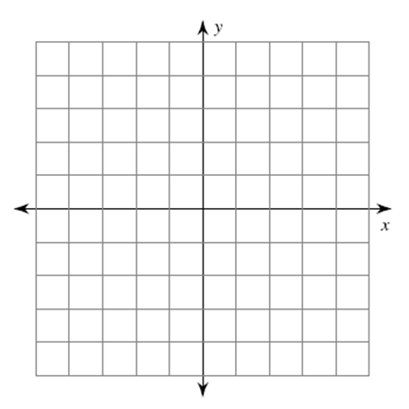

A

B
D
C

4. Translate the image (x + 5, y - 4).

3. Translate the image 4 units left and 2 units up.
A
C
B
A
C

B
D

5. Plot the points below and translate the image 3 units left and 1 unit down.
A(4,1) B(0,-2) C(1,0)

6. State the following translation in 3 ways.
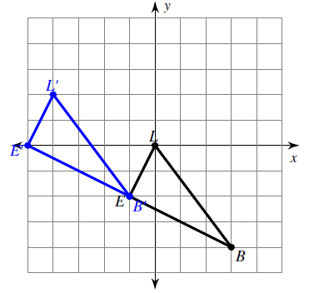
Words:
Mapping Notation:
Ordered Pair Notation:

7. Rotate the following images:

- Clockwise 90° b) Clockwise 180°

c) Clockwise 270°

8. Fixed Point Rotation
b) Rotate this shape around point B clockwise 180°.

a) Rotate this shape around point D clockwise 90°.

C
B
C
A
B
A

D

