C:\Users\Owner\AppData\Local\Microsoft\Windows\Temporary Internet Files\Content.IE5\3UCABMN4\MC900237503[1].wmfMeasurement Scavenger Hunt

Working with a partner, or by yourself, measure the following objects around the classroom. Remember to be respectful of others in the classroom. Also be respectful of Mr. Shuhyta’s stuff (please don’t break anything or Mr. Shuhyta will have to hurt you). Accuracy counts! Be precise.

|  |  |  |
| --- | --- | --- |
| **ITEM** | **MEASUREMENT** | |
| **METRIC** | **IMPERIAL** |
| Classroom Door Width |  |  |
| Classroom Wall Length |  |  |
| Classroom Desk Width |  |  |
| Recycling Bin Width |  |  |
| Chalkboard Height |  |  |
| An Unsharpened Pencil |  |  |
| A Whiteboard Marker |  |  |
| Length of Front Lab Bench |  |  |
| Filing Cabinet Height |  |  |

C:\Users\Owner\AppData\Local\Microsoft\Windows\Temporary Internet Files\Content.IE5\3UCABMN4\MC900215132[1].wmf

Measurement Hand In

Write down the exact measurements represented on each ruler.

**Part A:** **Metric**

E

D

C

B

A

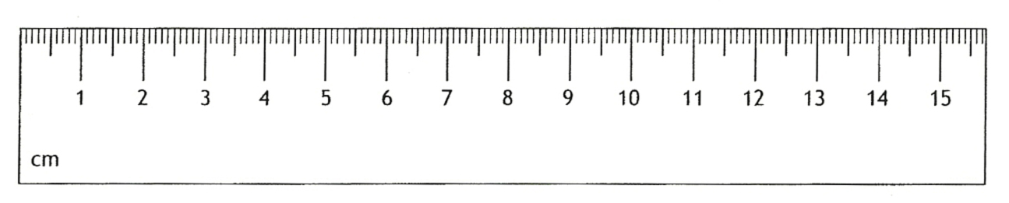

1. b) c)

d) e)

**Part B:** **Imperial**

B

D

E

C

A

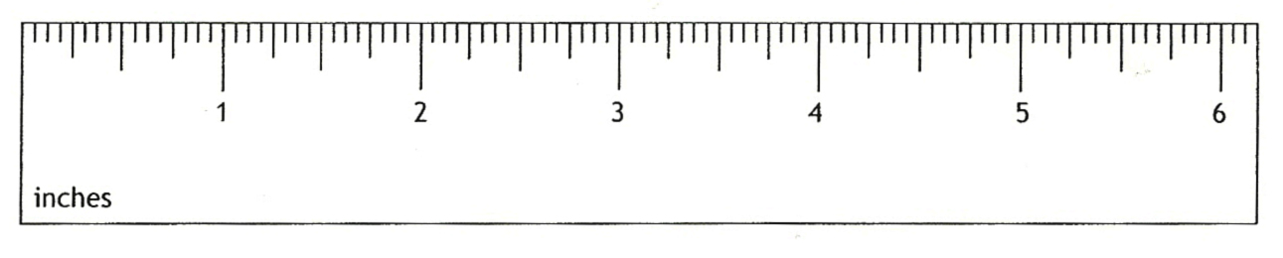

1. b) c)

d) e)